

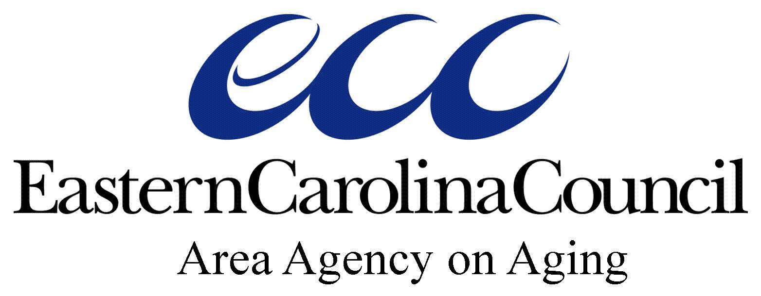

Eastern Carolina Council Area Agency on Aging  
233 Middle Street, New Bern, NC 28560

P.O. Box 1717, New Bern, NC 28563

(252) 638-3185

[www.eccog.org](http://www.eccog.org)



**OAA Title III-D DISEASE PREVENTION AND**

**HEALTH PROMOTION SERVICES**

**Eastern Carolina Council Area Agency on Aging**

**FY 2020 FUNDING APPLICATION PACKET**

**DUE DATE Wednesday, June 5 by 5:00 pm**

**Request for Proposal Applicant Eligibility: Government,  
Non-Profit and Faith-Based Organizations ONLY**

Refer to NC Division of Aging and Adults Services

Health Promotion Disease Prevention (OAA Title III-D)

Service Standards located on the website

[www.dhhs.state.nc.us/aging/svcstd/iiid.pdf](http://www.dhhs.state.nc.us/aging/svcstd/iiid.pdf)

### FY20 FUNDING NARRATIVE FOR

**OAA Title III-D Disease Prevention and Health Promotion Services**

### GENERAL INFORMATION

The objectives of Title III of the Older Americans Act (OAAA) are to:

1. Help older persons secure and maintain maximum independence and dignity in the community,
2. Remove barriers to independence for older persons, and
3. Provide a continuum of care for the vulnerable elderly.

Beginning in 2012, the focus on evidence-based health programs rose to the forefront of programming and today, funds administered through Title III-D must be used only for programs that are evidence-based. As of July 1, 2016, all programs offered under Title III-D funding must meet the highest-tier criteria.

**With funding from OAA Title III-D Disease Prevention and Health Promotion Services, Eastern Carolina Council Area Agency on Aging is seeking proposals from public and private non-profit organizations to provide approved evidence-based health promotion programs to older and disabled adults and their caregivers.**

Eastern Carolina Council will continue to fund only evidence-based health promotion (EBHP) programs that meet the highest level of criteria as designated by the Administration for Community Living (ACL) and which:

1. Have undergone experimental or quasi-experimental design and
2. In which full translation has occurred in a community site and
3. In which dissemination products have been developed and are available to the public.

The list of approved EBHP programs eligible for Title III-D funds for the Eastern Carolina Council region may be found at <https://www.ncoa.org/resources/ebpchart/>.

In order to be a successful applicant for the Title III-D Disease Prevention Health Promotion funds, candidates must:

* List the approved evidence-based health programs they would like to offer, anticipated schedule for offering each class, and provide a budget breakdown for each class series (include salary/fringe or contractor fees, supplies/materials, etc.)
* Meet the required 10% match. ECCAAA will only reimburse 90% of actual costs for approved, completed EBHP programs. All match must be in cash. **In-kind match is not permitted**. Applicants not directly affiliated with their respective County may contact their County to request coverage of the 10% match (at the discretion of the County). Otherwise, agency must secure the 10% match through other means and provide proof of such.

To receive reimbursement for a successfully completed EBHP class costs:

* Class must be instructed by at least one (1) agency staff person, subcontractor, or volunteer from the funded organization and trained in the specific program being offered.
* The Agency must inform ECCAAA **by email** of each workshop being considered for reimbursement **PRIOR** to the beginning of the workshop at least 4 weeks before the first class or session.
* The Agency is responsible for negotiating leader fees, volunteer stipends, mileage, etc. directly with each leader based on their relationship with that leader, even if ECCAAA has assisted in identifying a co-leader to teach the EBHP program.
* Class must adhere to ALL licensure standards set forth by the licensing agency (ECCAAA or other).
* Agency is responsible for assuring all leaders have received and maintain proper certification at the time of class(s) and must collect and retain proper documentation (e.g., certificates with expiration dates)
* As funds awarded under Title III-D are year-to-year grant awards**, all classroom-based workshops MUST be completed in their entirety before June 30, 2020 to be reimbursed**. Exceptions may be granted with written permission of ECCAAA – agencies MUST contact program coordinator for approval.
* Reimbursement will be made on a month-to-month basis provided proper documentation is submitted for work completed (even if class is still underway) **by the 5th of each month**. ECCAAA reserves the right to withhold reimbursement if adequate documentation is not provided.
* Agency may be required to return already reimbursed funds if agency does not complete instruction of all classes in the class block as required for program fidelity.
* All required paperwork must be submitted upon completion of the class within two weeks. Documentation may include but is not limited to sign-in sheets, evaluation forms, FY 19-20 HPDP Class Report Form (see Appendix A) and any other paperwork required by the program license or as specified by ECCAAA. It is the Agency Lead’s responsibility to ensure leaders have the most current required forms on the first day of each workshop series. Most recent forms for TaiChi, CDSME, Matter of Balance, and Walk With Ease can be found at <http://healthyagingnc.com/program-forms/>. Class completion documentation will be returned to the agency if most recent forms are not utilized. ECCAAA may withhold reimbursement or request return of funds if old forms are submitted and Agency does not provide updated documentation.
* All EBHP “classroom” programs **must have a minimum of 10 participants enrolled** to be eligible for reimbursement. It is recommended that agencies over-enroll prior to the beginning of the first class and that classes should adhere to the recommended size suggested by the licensing organizations. In the event a class has less than 10 participants, a waiver form must be submitted to ECCAAA for approval to conduct a class before the workshop begins or if there are less than ten at the first session (see Appendix B. Waiver for Reduction in EBHP Class Size). If prior approval is not received, the workshop will not be eligible for reimbursement.
* All agencies must comply fully with the individual EBHP program requirements to ensure fidelity and consistency. This may include but is not be limited to on-site class monitoring by trainers/licensing organization, participant evaluations, participation in data analysis, and leader screening and training.

**APPROVED EXPENSES:** Title III-D funds can only be spent on approved budgetary line items. Funds can be used for such items as staff salary and fringe directly linked to leading, promoting and/or directly coordinating the approved EBHP program, leader fees, volunteer stipend and mileage, leader training/certification costs, workshop materials and supplies, and participant recruitment. Any other expenses must be approved by ECCAAA and must clearly be associated with the dissemination of EBHP program(s). See Allowable Expense Definitions (Attachment 1).

All classroom-based workshops must be completed in their entirety by June 30, 2020. All workshops must be scheduled by April 1, 2020, unless prior written approval is received. Funds for EBHP programs not scheduled by the required date will be forfeited by the Agency and may be retained by ECC.

Funded agencies cannot subcontract any class to other agencies for implementation.

Title III-D funds may not be used for the following:

1. Services covered under Medicare or Medicaid
2. Prescription or over-the-counter drugs/medications
3. Medical services or purchase of durable medical equipment.
4. Indirect costs or administrative salaries.
5. Participant “incentives” and other promotional items not specifically required in program curricula
6. **Food or refreshments are NOT an allowable expenditure (except for MOB “healthy snacks”)**

**REPORTING REQUIREMENTS**

**Non-Unit Reimbursement Data Forms (DAAS-544)**

**Classes**: Reimbursement requests for salary/fringe, contractor fees, volunteer stipends, and mileage *associated with leading specific classes* will be approved on a monthly basis after required documentation has been submitted (Appendix A). See Attachment 3 for example of DAAS-544. Download form at <https://www2.ncdhhs.gov/AGING/arms/armsforms.htm>.

**Supplies/Materials/Participant Recruitment:** Reimbursement requests for supplies, materials, and participant recruitment will be approved monthly upon submission of Monthly Non-Unit Reimbursement Data form (DAAS-544).

**Training**: Reimbursement requests for leader training fees will be approved monthly as expenses occur using the Monthly Non-Unit Reimbursement Data form (DAAS-544). However, agency will be required to return any training fees if leader does not **successfully** complete the training. Reimbursement requests for lodging, meals and mileage associated with leader training will be approved once training is successfully completed.

**Monthly Non-Unit Reimbursement Data form (DAAS-544) is due by email to the ECCAAA Title III-D Program Manager by the 5th of each month. ECCAAA reserves the right to withhold reimbursement if adequate documentation is not provided.**

**Monthly Consumer Contribution/Program Income Form (DAAS-543)**

DAAS-543 form is due on the 5th of each month. See Attachment 4 for example of DAAS-543. Download form at <https://www2.ncdhhs.gov/aging/arms/forms/DAAS-543.pdf>

**Class Completion Form**

The Class Completion Form (Appendix A) is due within two (2) weeks of the last class in a class-block.

Please submit both DAAS 543 and DAAS 544 every month, even if no costs were incurred or contributions received.

### SELECTION CRITERIA

ECCAAA will fund HPDP programs based on the federal and state budget allocation to the region for the 2020 fiscal year. All allocations are contingent upon availability of funds and legislative priorities.

Agency may decide which program(s) to offer. However, priority may be given to agencies offering two or more “classroom” programs (e.g., CDSME programs, A Matter of Balance) in addition to movement-based programs (Arthritis Exercise, Tai Chi, etc.) and/or those proposing to reach currently under-served populations or geographic areas.

ECC will review each completed, on-time proposal, and multiple criteria will be considered when determining agencies approved, award amount, and number of programs and classes approved. Agency capacity, prior performance, completeness and clarity of application, and innovation/creativity will be considered. Based on the number of agencies applying, there is a possibility that an agency will not receive approval for all activities/items proposed. If this occurs, ECC will ask those agencies to submit a revised Budget Plan to match their award amount. Grant award notification letters will specify how much each grant award will be and which classes have been approved for reimbursement eligibility.

Selection criteria will include, but is not limited to:

1. Reasonableness of line item budgets for tasks and activities proposed;
2. Demonstrated capacity, past history and performance on previous Title III-D grants executed with ECCAAA; and
3. Other applications received proposing to serve similar geographic areas or target populations.

**APPLICATION REQUIREMENTS**

**SECTION I. EBHP PROGRAMS (REQUIRED)**

All EBHP programs selected must be from the ACL approved list of Highest Tier Evidence-Based Health Promotion programs (see <https://www.ncoa.org/resources/ebpchart/>).

**SECTION II. CONSUMER CONTRIBUTIONS (REQUIRED)**

Because EBHP workshops utilizing Title III-D funds cannot have a fee or charge associated with them in any way, applicants must develop a plan to solicit and accept voluntary contributions. All proceeds received will be entered in NC ARMS (Aging Resources Management System) by the agency and must go toward the expansion of allowable Title III-D programs only.

Successful applicants must comply with the NC Division of Aging and Adult Services Consumer Contribution Policy found at <https://www.ncdhhs.gov/consumer-contributions-policy-and-procedures>

**SECTION III. BUDGET (REQUIRED)**

1. Completed Budget Worksheet
2. Completed Line Item Budget of expenses.
3. Signed Standard Assurances (Attachment 2)

COMPLETED COPY OF PROPOSAL WITH ORIGINAL SIGNATURES IS DUE TO  
EASTERN CAROLINA COUNCIL AREA AGENCY ON AGING BY   
5:00 PM ON Wednesday, June 5, SEND TO:

EASTERN CAROLINA COUNCIL

ATTENTION JENNY MILLER

PO BOX 1717

NEW BERN, NC 28563

(NO EMAIL OR FAXED PROPOSALS WILL BE ACCEPTED)

AWARDS WILL BE ANNOUNCED AND CONTRACTS WILL BE   
DISTRIBUTED UPON APPROVAL.

**FUNDING NARRATIVE**

**OAA Title III-D HEALTH PROMOTION DISEASE PREVENTION PROGRAMS**

**FY 19-20**

# DATE:       COUNTY:

# AGENCY:

# PROJECT LEAD:

# ADDRESS:

PHONE:       EMAIL:

NAME OF SUPERVISOR AND OTHER KEY STAFF FOR THIS PROJECT:

COMPONENT I: EBHP COMPONENT (REQUIRED)

I. Which programs do you propose to offer and how many of each?

List the number of Class Blocks (full workshops) your Agency will offer of each EBHP:

|  |  |
| --- | --- |
| EBHP Program | Number of Class Blocks |
|  |  |
|  |  |
|  |  |
|  |  |
|  |  |
|  |  |
| Total |  |

I.B. How will you promote EBHP programs and recruit participants for workshops (be specific)?

I.C. How will you identify, recruit, and retain EBHP program leaders for proposed program offerings?

**COMPONENT II: CONSUMER CONTRIBUTIONS (REQUIRED)**

NC DAAS Health Promotion and Disease Prevention Program Standards, Section VII. B. Records, Reports and Reimbursement, page 8: *“Voluntary Contributions: In accordance with the requirements of the Older Americans Act, agencies must provide individuals receiving service the opportunity to contribute to the cost of the service. Eligible persons receiving Health Promotion and Disease Prevention services are subject to these requirements. Agencies must establish written policies and procedures governing the collection of voluntary contributions.”*

**PLEASE ATTACH A COPY OF YOUR CURRENT POLICY AND PROCEDURES THAT OUTLINE THE COLLECTION AND REPORTING OF YOUR CONSUMER CONTRIBUTIONS.**

II.A. Agencies providing EBHP programs with Title III-D funding cannot charge participants for those classes or services. Describe how your agency will solicit consumer contributions for recipients of EBHP programs.

**COMPONENT III: BUDGET (REQUIRED) Complete Attachment III. Budget**

III.A. The Budget Worksheet is attached.

III.B. The line item Budget is attached.

III.C. The Standard Assurances Form is signed and attached.

III.D. (NON-PROFIT ONLY) A copy of the signed Conflict of Interest Policy is attached.

III.E. (First Time Applicants Only )

* A copy of the most recent agency audit.
* A copy of the agency organizational chart.

See last page of RFP for total allocation limits for each county.

**Attachment I**

**Allowable Expense Definitions**

**Eastern Carolina Council Area Agency on Aging (ECCAAA)**

**EBHP Proposal Budget Definitions**

1. **Staff Salary and Fringe** – This item is allowable only for agency staff directly involved in teaching, coordinating/arranging, or being trained as a leader for approved EBHP. Allowable costs include time spent leading workshops, attending training, conducting marketing and outreach activities, screening and registering participants, preparing and planning for workshops, traveling to trainings, and performing any activity directly related to receiving and/or maintaining leader certification.
2. **Sub-Contracted Leader Fees** – These are fees paid to *professional certified leaders* that teach an approved EBHP**\***.
3. **Volunteer Leader Reimbursement** – Leaders not employed by the agency can be reimbursed for stipends, mileage or out-of-pocket expenses to lead approved EBHP. This is at the discretion of the agency but should be comparable to the going rate for leaders/facilitators of other programs based on the relationship of the agency with the volunteer.
4. **Materials and Supplies** – Supplies needed to lead the EBHP can be purchased to ensure successful completion of the workshops such as books, manuals, copies, flip charts, markers, folders, paper/tablets, and paper products (for MOB only – cups, plats, etc.). Supplies must be directly related to the accomplishment of the EBHP ONLY and cannot be used for other purposes. Basic janitorial supplies are not allowable.
5. **Travel/Mileage** – For both volunteers and staff as they lead workshops in the community, attend leader activities such as trainings and outreach events. Funds cannot be used to pay mileage or transportation costs of participants.
6. **Participant Recruitment**. – These line items allow expenses associated with marketing the EBHP to the community such as media and/or advertising costs, and printing/copying of flyers and newsletters. If packaged with other programs for advertising, the cost MUST be prorated based on the amount of space devoted to the EBHP program(s). Promotional items or “giveaways” are not allowed.
7. **EBHP Leader Training and Certification Costs** - Allowable expenses include leader registration fees for approved EBHP Programs and any travel expenses associated with certification (hotel, food, etc.). Licensure costs can also be included.

*All appropriate documentation including but not limited to receipts, payroll reports, copies of contracts with non-employee leaders, and leader certifications must be maintained by Agency.*

***\* If ECCAAA staff needs to fill in for an absent instructor, a fee will apply and will be deducted from your allocated amount.***

**Attachment 2  
STANDARD ASSURANCES**

1. Services will be provided in accordance with requirements set forth in:

* Eastern Carolina Council Area Agency on Aging Procedures Manual <http://www.eccog.org/documents-resources/>
* The North Carolina Division of Aging and Adult Services Health Promotion and Disease Prevention Standards
* The NC Division of Aging and Adult Services Policies and Procedures.
* The Older Americans Act of 1965.

2. Priority will be given to providing programs to older persons with the greatest economic or social needs, with particular attention to low-income minority individuals.

3. All licenses, permits, bonds, and insurance necessary for carrying out services will be maintained by the Community Service Provider and any contracted providers.

4. Certification, State Grants compliance reporting. If the contractor is a governmental entity, such entity is subject to the provisions of the requirements of OMB Uniform Guidance 2 CFR Part 200 and the NC Single Audit Implementation Act of 1987. Non-government agencies must comply with GS 143C-6-23 as outlined in the chart below.

|  |  |  |
| --- | --- | --- |
| **NON-PROFIT ONLY**  **Required State Grants Reporting** | | |
| $1 - $24,999 | $25,000 - $499,999 | $500,000 and more |
| Certification Form | Certification Form | Certification Form |
| Brief accounting and program activities and accomplishments | More detailed accounting (schedule of receipts and expenditures) | Audit and  Schedule of Awards  (usually included in audit) |
| Due within six (6) months of entity’s fiscal year to ECCAAA | Due within six (6) months of entity’s fiscal year to ECCAAA | Due within nine (9) months of entity’s fiscal year to ECCAAA and Office of the State Auditor |
| N/A | Separate program activities and accomplishments | Program activities and accomplishments |

5. Compliance with Equal Employment Opportunity requirements shall be followed.

6. The Community Service Provider will be monitored through on-site visits by the Area Agency on Aging to assure that services are being provided in compliance with the provisions of the contract.

7. The Community Service Provider will submit both monthly financial and quarterly program reports as required by the Area Agency on Aging and the NC DAAS.

8. The Community Service Provider assures that the required 10% match will be provided.

9. The Community Service Provider assures that all consumer contributions collected will be used to expand the Health Promotion Disease Prevention Service.

10. The Community Service Provider assures that all terms and conditions as required by the Older Americans Act of 1965, the North Carolina Division of Aging and Adult Services, and Eastern Carolina Council Area Agency on Aging will be adhered to.

**___________ _____________________________ ____________________________**

Date Signature/Title Service Providing Agency

**Attachment 3**

**Example of DAAS-544**

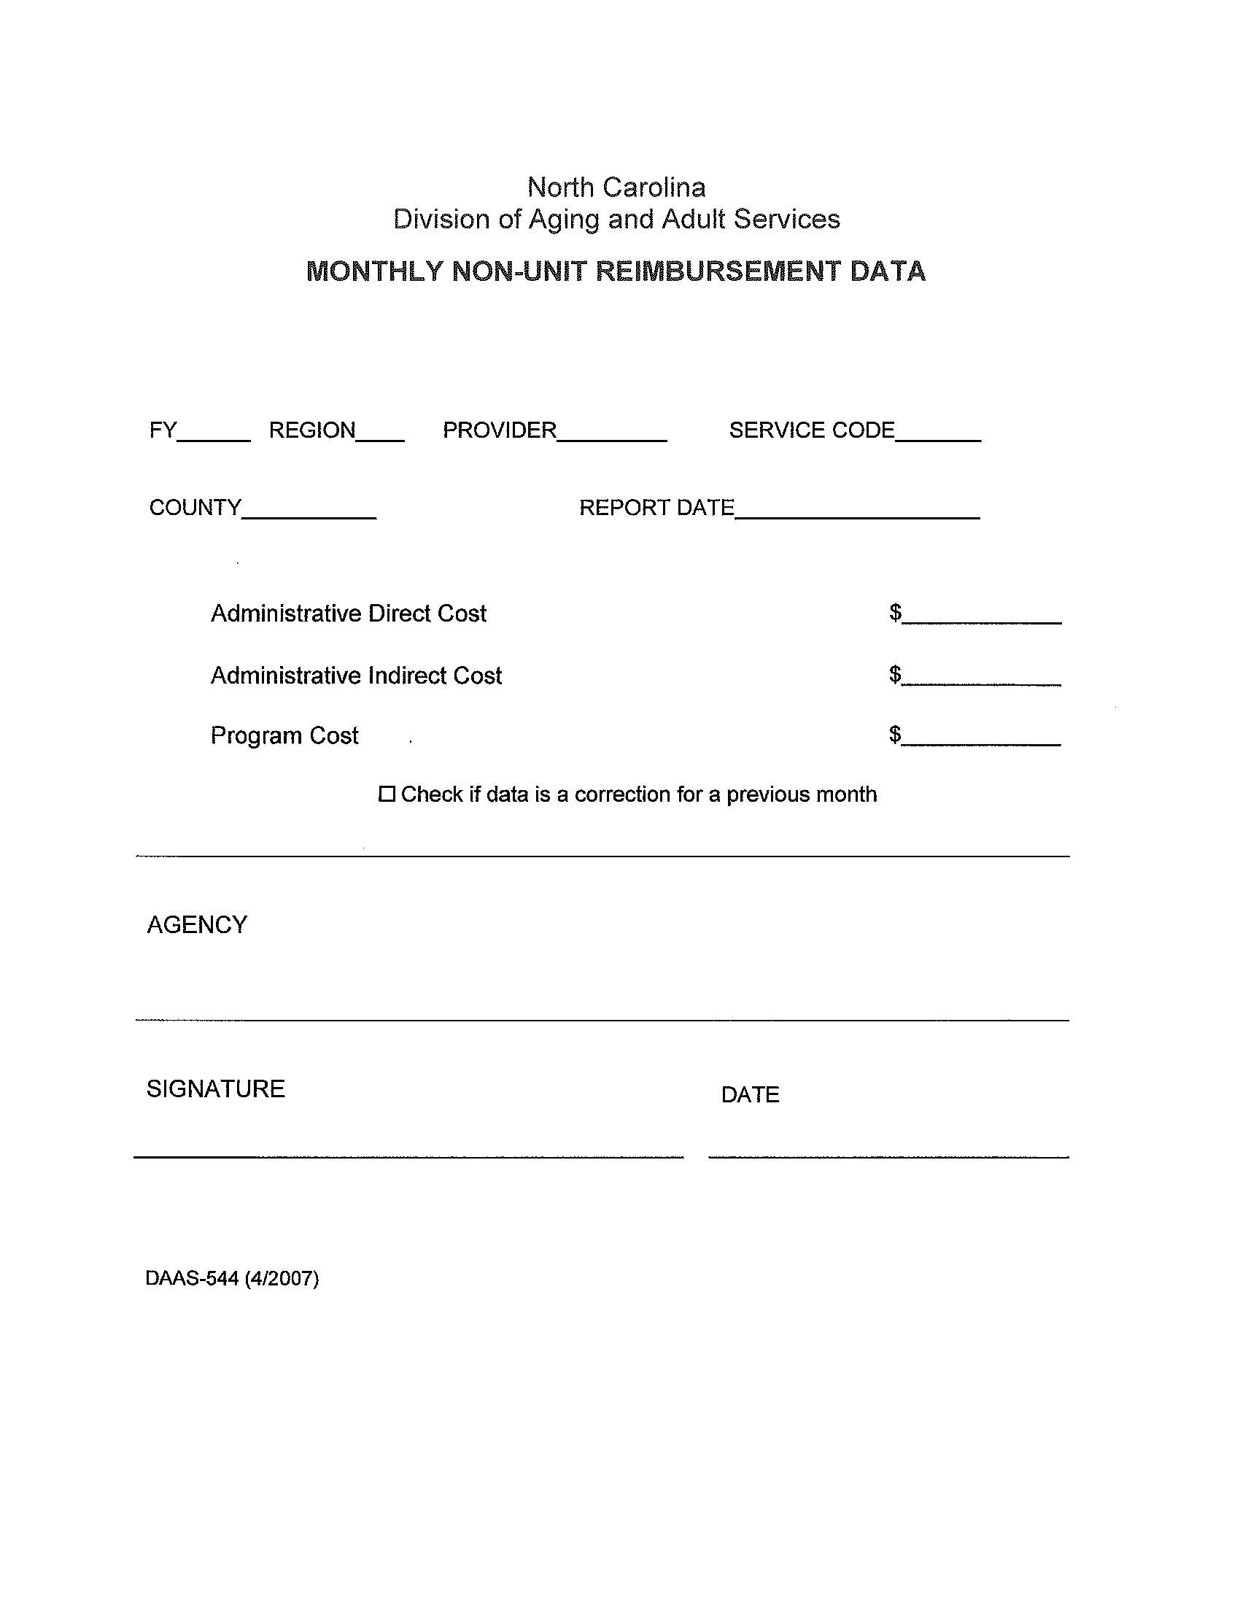

**Attachment 4**

**Example of DAAS-543**

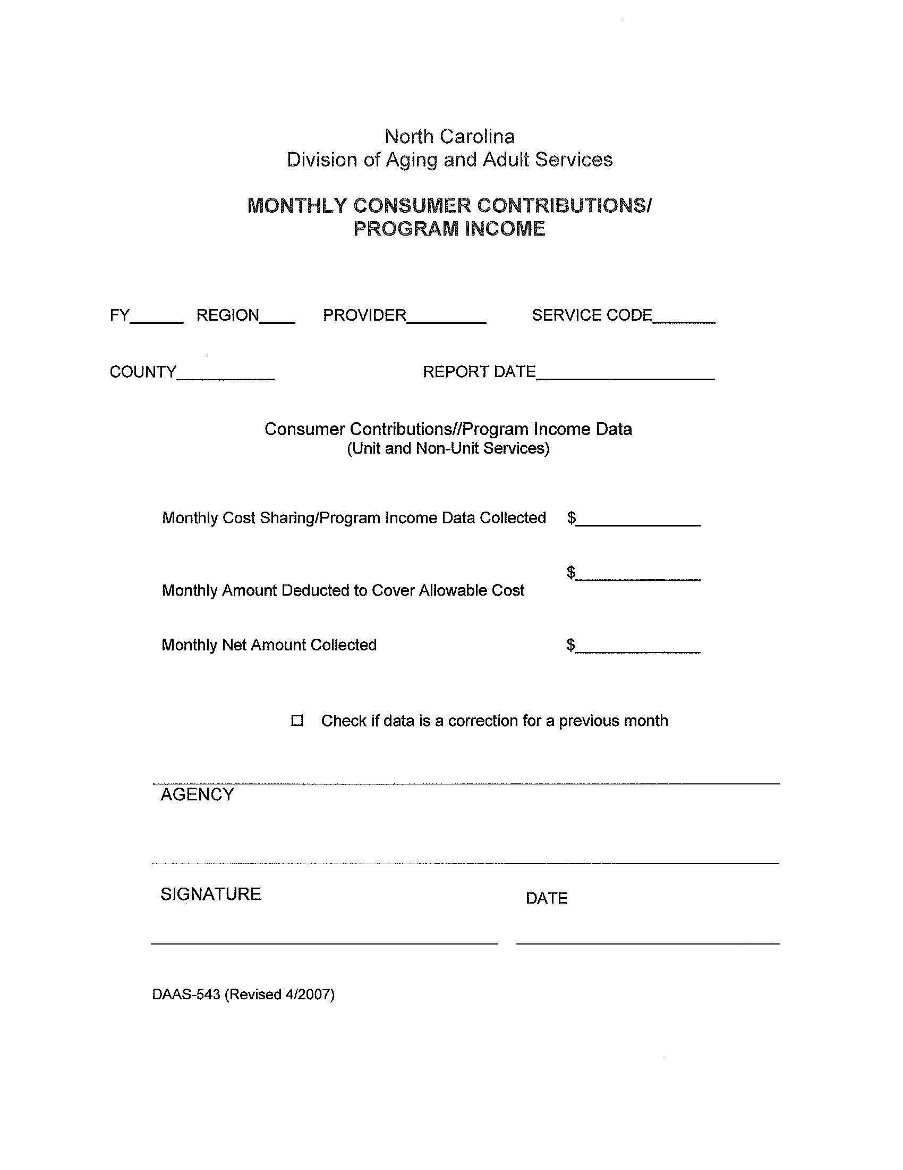

**Attachment 5**

**Budget Worksheet and Budget Plan Spreadsheet**

**Instructions:**

* **Double-click on the Budget Worksheet Excel icon below**
* **Complete the budget estimate**
* **Print and insert into completed and signed RFP document**



**APPENDIX A**

**Eastern Carolina Council Area Agency on Aging**

**Health Promotion Disease Prevention (HPDP) Title III-D**

**EBHP Class Participation Report Form FY 19-20**

Complete one form and attach with all required paperwork for each program successfully COMPLETED in order to be reimbursed.

|  |
| --- |
| County ___________________________________ Date ________________________________  Agency Name ____________________________________________________________________________    Name of Person Completing Form: ___________________________________________________________  Telephone: _________________________________ Email: _______________________________________ |
| **Program Completed: ______________________________________________________________________**  Class started on __________________ and ended on ________________________  Number of sessions ____________ Number of total participants ______________  Number of participants who completed 5 of 8 classes (MOB) _____________ 4 of 6 (CDSME) ____________  66% (Arthritis Exercise) ____________  Leader Names 1. _________________________________________________________  2. _________________________________________________________  Place/Location_____________________________________________________________ |

**Please *make a copy for your records* and submit completed form with required documentation to**:



Andi Reese

Eastern Carolina Council Area Agency on Aging

P.O. Box 1717

New Bern, NC 28563

Phone: (252) 638-3185 ext. 3015

Fax: (252) 638-3187 Email: [areese@eccog.org](mailto:areese@eccog.org)

**See next page for required documentation for commonly offered EBHP Program.**

|  |  |
| --- | --- |
|  | **REQUIRED DOCUMENTATION** |
| All CDSME Workshops | Attendance Log/Sign In Sheet, Participant Information Survey, Workshop Information Cover Sheet and Class Evaluations |
| Matter of Balance | Attendance Sheet/Sign In Sheet, Pre-class (First Class) Survey, Post-class (Last Class) Survey, and Class Evaluations |
| Arthritis Exercise | Attendance Sheet/Sign In Sheet |
| Tai Chi for Arthritis/Fall Prevention | Attendance Sheet/Sign In Sheet, Class Info Cover Sheet, First Session Survey and Last Session Survey |

*Thank you for your ongoing support of evidence-based health programs!*

 **Eastern Carolina Council Area Agency on Aging**

**Health Promotion Disease Prevention**

**Title III-D Funding**

**FY 19-20**

**APPENDIX B**

**WAIVER FOR REDUCTION IN EBHP CLASS SIZE**

**County: ___________________________ Agency: ____________________________________**

**Workshop Title: _________________________________________________________________**

**Person Completing Form: _________________________________________________________**

The HPDP Title III-D proposal requires that all evidence-based “classroom” workshops are to be conducted with a minimum of ten (10) participants in order to receive reimbursement. Workshops which do not have at least ten confirmed participants prior to starting or do not have at least ten participants at the very first class session must submit a Waiver for Reduction in Class Size form. ECCAAA may approve exceptions to this requirement. Please complete form prior to beginning the workshop or after the first class session and submit to ECC. You will receive a response to your request within one (1) business day.

DESCRIBE RECRUITMENT ACTIVITES FOR THIS WORKSHOP:

DESCRIBE REASON FOR EXCEPTION:

Signed:____________________________________ Date:______________________

**Please complete form and email it to:**

Andi Reese, Human Services Deputy Director

Eastern Carolina Council

Email: [areese@eccog.org](mailto:areese@eccog.org)

**EASTERN CAROLINA COUNCIL AAA USE ONLY:**  RECEIVED DATE ______________

ACCEPTED ____________ DENIED ____________

SIGNATURE ____________________________________________ DATE _________________________

**Eastern Carolina Council Area Agency on Aging**

**Available Funding for Title III-D Programs**

**FY 19-20**

Agency may request up to the Total Grant amount shown for each County. All grantees must guarantee the 10% match.

|  |  |  |  |
| --- | --- | --- | --- |
| **County** | **Total Grant** | **10% Match** | **Total Program Cost** |
| Carteret | 5,197 | 577 | 5,774 |
| Craven | 5,904 | 656 | 6,560 |
| Duplin | 5,018 | 588 | 5,576 |
| Greene | 2,135 | 237 | 2,373 |
| Jones | 1,575 | 175 | 1,750 |
| Lenoir | 5,137 | 571 | 5,707 |
| Onslow | 6,902 | 767 | 7,669 |
| Pamlico | 1,877 | 209 | 2,085 |
| Wayne | 7,738 | 860 | 8,598 |