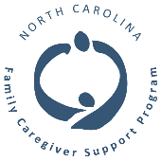
WAYNE COUNTY
FAMILY CAREGIVER SUPPORT PROGRAMS
Eastern Carolina Council Area Agency on Aging: (252) 638-3185; www.eccog.org.
  - Address: 233 Middle Street, 3rd Floor, New Bern NC
  - Services: Caregiver information and assistance, caregiver one-on-one options counseling, support and training, information and referral programs, literature, Long Term Care Ombudsmen program, advance care planning and document education and assistance.

Wayne County Department of Social Services: (919) 580-4034; http://www.waynegov.com/Page/417
  - Address: 301 N. Herman Street, Goldsboro
  - Services: Medicaid Applications, Nursing Home Placement, In-Home Personal Care Aide assistance, Adult Protective Services, eye care certifications, services for the blind, Special Assistance, Food Stamp Eligibility, Legal; Assistance, Transportation, and Energy Assistance Program.

Wayne County Services on Aging (Senior Center): (919) 731-1591; https://www.waynegov.com/360/Services-on-Aging
- Address: E. Ash St., Goldsboro
  - Services: Group Respite, Consumer Directed Caregiver Voucher Program, Transportation, Congregate Meal Site, In-Home Aide Programs, Home Health Services, Home Delivered Meals, activities, fitness, health and Wellness, Nutrition, SHIIP/Medicare counseling, volunteer opportunities, caregiver lending library, legal services, small home repairs, notary services, Advance Care Planning services, activities, and fitness classes.
WAGES: (919) 734-1178
  - Address: 800 Main St., Alliance NC
  - Services: Exercise Classes, Fitness Center, Senior Games/ Silver Alerts, Health Screenings, Senior Companion Program, Educational Programs, SHIP Counseling, and Alzheimer’s Resources, Congregate Nutrition, Daily lunches for Seniors Age 60+ served at 11:30am; Home Delivered Meals for Seniors Age 60 and Above Legal Services, Transportation, Small Home Repair, Referrals, Housing Assistance, Emergency Assistance, In-Home Services, etc.
CAREGIVER SUPPORT GROUP
- Every Friday at 5:30 pm-Alzheimer’s Support Group, 2001 E Ash St., Goldsboro
- 4th Monday of each month at 5:00 p.m.-Caregiver Support Group; 2001 E Ash St., Goldsboro
- 3rd Saturday of every month at 11:30 a.m.-Deaf and Hard of Hearing Support Group; 2001 E Ash St., Goldsboro
CAREGIVER RESOURCES
- AARP of North Carolina: 1-866-389-5650; www.aarp.org
- Alzheimer’s Association: Caregiver help line: 1-800-272-3900, www.alz.org
- Dementia Alliance of North Carolina: Caregiver assistance line: 1-800-228-8738; www.dementianc.org
- GATEWAY Transportation Authority: (919) 736-1374
- Wayne County Health Department: (919) 731-1000
- International Hearing Society (Hearing Aid Helpline): 1-800-521-5247
- Legal Aid of NC: 1-866-219-5262; www.legalaidnc.org
- Long Term Care Regional Ombudsman: Colby Smith, (252) 638-3185 or 1-800-824-4648
- Medicare: 1-800-633-4227; www.medicare.gov
- NC Assistive Technology: (919) 859-8360, www.ncdhhs.gov
- NC Baptist Aging Ministry (NCBAM): 1-877-506-2226, www.ncbam.org
- NC Division of Health & Human Services: 1-800-662-7030; www.ncdhhs.gov
- NC Independent Living Program: 1-877-699-7578
- NC Lions Foundation (visually and hearing-Impaired assistance): 1-800-521-5247
- Nursing Home Complaint Hotline: 1-800-624-3004
- Project C.A.R.E-Caregivers Alternatives to Running on Empty: Amanda Biggs, (252) 414-3230
- Senior Health Insurance Information Program (SHIIP): 1-855-408-1212; www.ncdoi.com/SHIIP
- Social Security Administration: 1-800-772-1213
- U.S. Department of Veterans Affairs: 1-844-698-2311; www.va.gov
TOLL-FREE INDIVIDUAL ASSISTANCE/CRISIS HOTLINES
- Alzheimer’s Foundation of America Caregiver Assistance Line: 1-866-232-8484; www.afadn.org
- Caregiver Connection Assistance Line: 1-866-211-3380
- United Way NC211 Helpline: 211; www.nc211.org
- Veterans Crisis Line: 1-800-273-8255; www.va.gov
NC LICENSED HOME CARE & HOME CARE
- 3HC: (919) 735-1386
- A Primary Choice, Inc.: (919) 705-5955
- ARRKKA Healthcare Agency, Inc.: (919) 736-3384
- Bryant Home Care Solutions, LLC: (919) 9225803
- CPS Home Care: (877) 213-3533
- Community home Care and Hospice: (919) 734-7011
- Crossroads Support Services, Inc.: (919) 736-9242
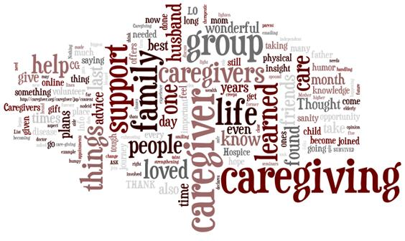
- Extended Hearts Home Care: (919) 722-9069
- Halikierra Home Care: (888) 243-1319
- Howell Support Services: (919) 919-778-1506
- Kindred at Home: (919) 731-7254
- Personal Homecare Solutions, Inc.: (919) 580-9045
- Resparacare, Inc.: (919) 580-9898
- St. Vincent Home Care Agency: (919) 731-4850
CON’T - NC LICENSED HOME CARE & HOME CARE
- United Home Care, Inc.: (919) 759-4025
- Wayne County Services for Aging: (919) 731-1591
- Well Care Home Care: (919) 778-8212
- Xeon Home Healthcare Services: (919) 658-0500
Adult Care Homes (Assisted Living Facilities)
- Brookdale Berkley Boulevard: 1800 N. Berkley Blvd., Goldsboro NC; (919) 759-1900
- Brookdale Country Day Road: 380 Country Day Rd, Goldsboro NC; (919) 735-5117
- Eagle Point: 901 W. New Hope Rd, Goldsboro; (919) 587-1747
- Countryside Living: has a dementia unit; 5383 NC HWY 117, Pikeville NC; (919) 242-6369
- Freemont Rest Center: 300 S. Vance St, Freemont NC; (919)424-6161
- Goldsboro Assisted Living & Alzheimer’s Care: has a dementia unit, 2201 Royal Ave, Goldsboro NC; (919) 735-7684
- Lagrange Gardens: 167 Fussel Rd, LaGrange, NC; (252) 566-4112
- Re NuLife: 501 Forest Hills Dr., Goldsboro NC; (919) 734-0266
- Somerset Court: 603 Lockhaven Court, Goldsboro NC; (919) 580-0590
- Suttons Rest Home: 4258 US Hwy 13 N, Goldsboro NC; (919) 759-9695
- Woodard Retirement Village: has a dementia unit; 1019 Royale Ave., Goldsboro NC; (919) 731-2855
- Woodard Care, Inc.: has a dementia unit; US HWY 70 W, Goldsboro NC; (919) 734-2889
- Wayne County Rest Villa No. 1: 305 Vance St., Fremont NC; (919) 242-6161
- Wayne County Rest Villa No. 2: 305 Vance St., Fremont NC; (919) 242-6161
NC LICENSED-LONG TERM CARE, SKILLED NURSING FACILICITIES
- Brian Center of Goldsboro: 1700 Wayne Memorial Dr., Goldsboro NC; (919) 731-2805
- Mount Olive Center: PO Box 1079, Mt. Olive NC; (919) 658-9522
- Willow Creek Nursing and Rehabilitation Center: 2401 Wayne Memorial Dr., Goldsboro NC; (919) 736-2121

DHSR facility licensing information, licensed facility information, and survey results available at: www.ncdhhs.gov
For further information and assistance contact:

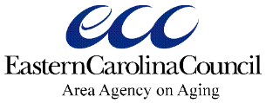

Aging Program Consultant- Family Caregiver Resource Specialist: (252) 638-3185

Long Term Care Ombudsmen:
1-800-824-4648

Visit us at:
www.eccog.org

Revised: 7/26/22, JB

